1) Which feature most strongly identifies a Divergent Channel rather than a Primary Channel?
A) A point-by-point surface route
B) A deep route that enters zangfu and converges with a paired Yang pathway +++++
C) A branch that begins at a Luo point
D) A broad superficial route that binds at joints
Feedback: Divergent Channels are recognized by deep entry, paired zangfu relationships and convergence with a Yang pathway. Why are the other options incorrect? A point-by-point surface route — A point-bearing surface route characterizes a Primary Channel. A branch that begins at a Luo point — A branch from a Luo point characterizes a Luo-Connecting Channel. A broad superficial route that binds at joints — A broad superficial binding route characterizes a Sinew Channel.
2) What does a typical Yang Divergent Channel do after separating from its Yang Primary Channel?
A) It enters the Yang organ and its paired Yin organ. +++++
B) It remains entirely superficial.
C) It begins at the paired Yin channel’s Luo point.
D) It ends at the first joint it reaches.
Feedback: A Yang Divergent Channel typically enters both its related Yang organ and the internally–externally paired Yin organ. Why are the other options incorrect? It remains entirely superficial. — Remaining entirely superficial would omit the characteristic deep entry. It begins at the paired Yin channel’s Luo point. — Beginning at a Luo point describes Luo-Connecting organization. It ends at the first joint it reaches. — Divergent routes continue toward convergence rather than ending at the first joint.
3) How does a typical Yin Divergent Channel reconnect?
A) It forms an independent point sequence.
B) It joins the paired Yang Divergent route and then the paired Yang Primary Channel. +++++
C) It returns only to its own Yin Primary Channel at the wrist or ankle.
D) It ends in a muscle binding region.
Feedback: A Yin Divergent route connects with its paired Yang Divergent pathway and joins the paired Yang Primary Channel. Why are the other options incorrect? It forms an independent point sequence. — Divergent Channels do not have independent acupuncture-point sequences. It returns only to its own Yin Primary Channel at the wrist or ankle. — The defining model emphasizes convergence with the paired Yang route, not only return to its own Yin channel. It ends in a muscle binding region. — Muscle binding regions are characteristic of Sinew Channels.
4) Which statement about acupuncture points on Divergent Channels is correct?
A) Each Divergent Channel has its own numbered point sequence.
B) Only Yin Divergent Channels have numbered points.
C) Divergent Channels do not have an independent sequence of acupuncture points. +++++
D) Every Divergent point is also a Luo point.
Feedback: Divergent Channels are pathways associated with the Primary Channels and do not have their own independent numbered point sequence. Why are the other options incorrect? Each Divergent Channel has its own numbered point sequence. — The numbered point sequence belongs to the Primary Channel network. Only Yin Divergent Channels have numbered points. — Neither Yin nor Yang Divergent routes have an independent numbered point sequence. Every Divergent point is also a Luo point. — Luo points originate Luo-Connecting routes and are not synonymous with Divergent pathways.
5) Which sequence best summarizes Divergent Channel organization?
A) Separate, enter deeply, converge, rejoin +++++
B) Begin at a Luo point, cross to a paired channel, end superficially
C) Begin at a toe or finger, bind at joints, spread through muscles
D) Circle the waist, ascend the midline, enter the brain
Feedback: Separation, deep entry, convergence and rejoining form the core recognition sequence for Divergent Channels. Why are the other options incorrect? Begin at a Luo point, cross to a paired channel, end superficially — This sequence describes Luo-Connecting organization. Begin at a toe or finger, bind at joints, spread through muscles — This sequence describes Sinew Channel organization. Circle the waist, ascend the midline, enter the brain — This combines selected Extraordinary Vessel features rather than the Divergent model.
6) A deep branch separates near the posterior knee, relates to the Bladder and Kidney, then ascends toward the spine and nape. Which pathway is the best match?
A) Bladder Divergent Channel +++++
B) Bladder Luo-Connecting Channel
C) Bladder Sinew Channel
D) Kidney Primary Channel
Feedback: The posterior-knee separation, deep Bladder–Kidney relationship and ascent toward the spine and nape identify the Bladder Divergent pathway. Why are the other options incorrect? Bladder Luo-Connecting Channel — The Bladder Luo route begins at BL-58 and is organized as a connecting branch. Bladder Sinew Channel — The Bladder Sinew route is superficial and musculotendinous rather than a deep zangfu pathway. Kidney Primary Channel — The Kidney Primary Channel is a Foot Yin point-bearing route, not this Yang Divergent pattern.
7) A pathway from the foot and genital region joins the Gall Bladder Divergent pathway. Which channel is described?
A) Liver Divergent Channel +++++
B) Liver Luo-Connecting Channel
C) Gall Bladder Sinew Channel
D) Dai Mai
Feedback: The Liver Divergent Channel separates from the Liver Primary route, relates to the genital region and joins the paired Gall Bladder Divergent pathway. Why are the other options incorrect? Liver Luo-Connecting Channel — The Liver Luo route begins at LIV-5 and has a different connecting-pathway organization. Gall Bladder Sinew Channel — The Gall Bladder Sinew route is a lateral superficial body chain. Dai Mai — Dai Mai is recognized by its transverse belt-like course around the waist.
8) Why can Divergent Channels help explain paired Yin–Yang relationships beyond the superficial Primary routes?
A) They enter paired zangfu and converge through the Yang pathway. +++++
B) They replace all Primary Channels.
C) They consist only of cutaneous regions.
D) They are defined by the color used in the diagram.
Feedback: Deep entry into paired zangfu and convergence through a Yang route extend the internal–external relationship beyond the ordinary surface map. Why are the other options incorrect? They replace all Primary Channels. — Divergent pathways supplement rather than replace Primary Channels. They consist only of cutaneous regions. — Cutaneous regions are a separate channel-system concept. They are defined by the color used in the diagram. — Diagram color is not a defining functional relationship.
9) What is the channel shown in the image?
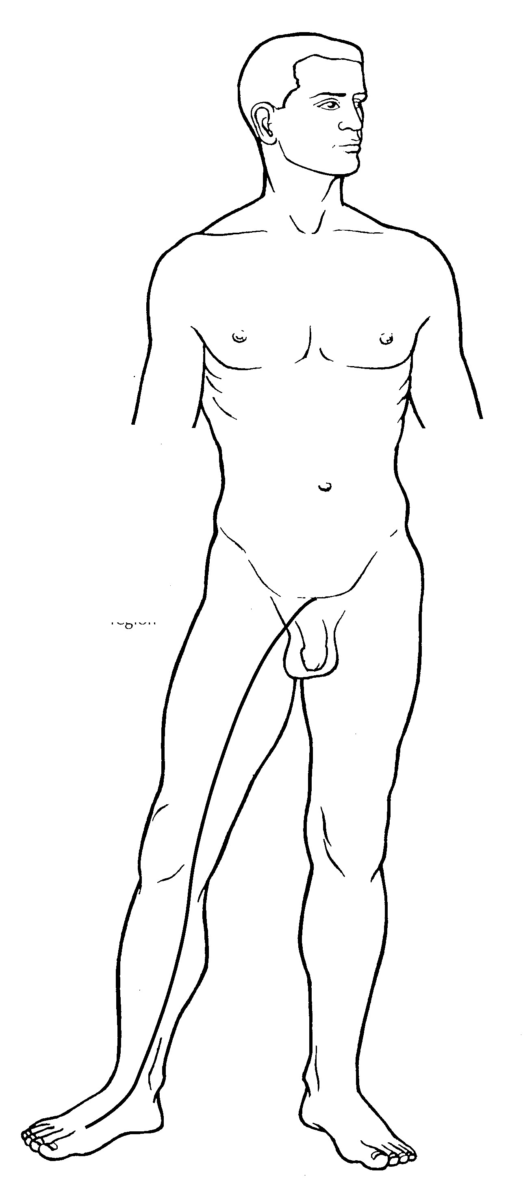
A) Liver Primary Channel
B) Liver Divergent Channel +++++
C) Liver Luo-Connecting Channel
D) Liver Sinew Channel
Feedback: The Liver Divergent Channel is identified by its ascent from the foot and medial leg toward the pubic and genital region, followed by deep convergence with the paired Gall Bladder Divergent pathway. Why are the other options incorrect? Liver Primary Channel — The Primary Channel is the ordinary point-bearing Foot Yin route. Liver Luo-Connecting Channel — The Luo-Connecting Channel begins at LIV-5 and has a characteristic genital continuation. Liver Sinew Channel — The Sinew Channel is a superficial musculotendinous pathway.
10) What is the channel shown in the image?
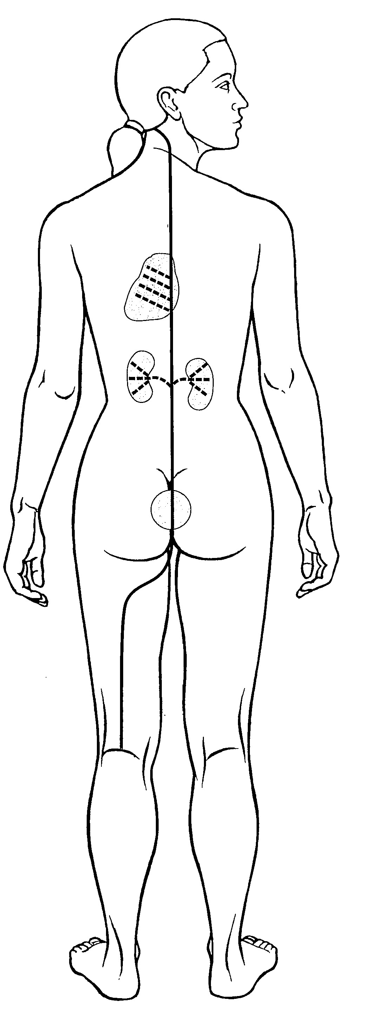
A) Bladder Divergent Channel +++++
B) Bladder Luo-Connecting Channel
C) Bladder Sinew Channel
D) Bladder Primary Channel
Feedback: The Bladder Divergent Channel separates near the popliteal region, enters deeply to connect with the Bladder and disperse through the Kidney, then ascends beside the spine toward the Heart, emerges at the neck and rejoins the Bladder Primary Channel. Why are the other options incorrect? Bladder Luo-Connecting Channel — The Luo-Connecting Channel begins at BL-58 and connects with the Kidney Channel. Bladder Sinew Channel — The Sinew Channel is a broad superficial posterior chain. Bladder Primary Channel — The Primary Channel is the ordinary point-bearing posterior pathway.

